Palmyra and the Civil War

On 29 Jun, and 2&3 July 1860 Albert Wells recorded the decennial census for Cinnaminson Township, which included what are now Palmyra and Riverton, as well as Cinnaminson. As this 1859 map shows,
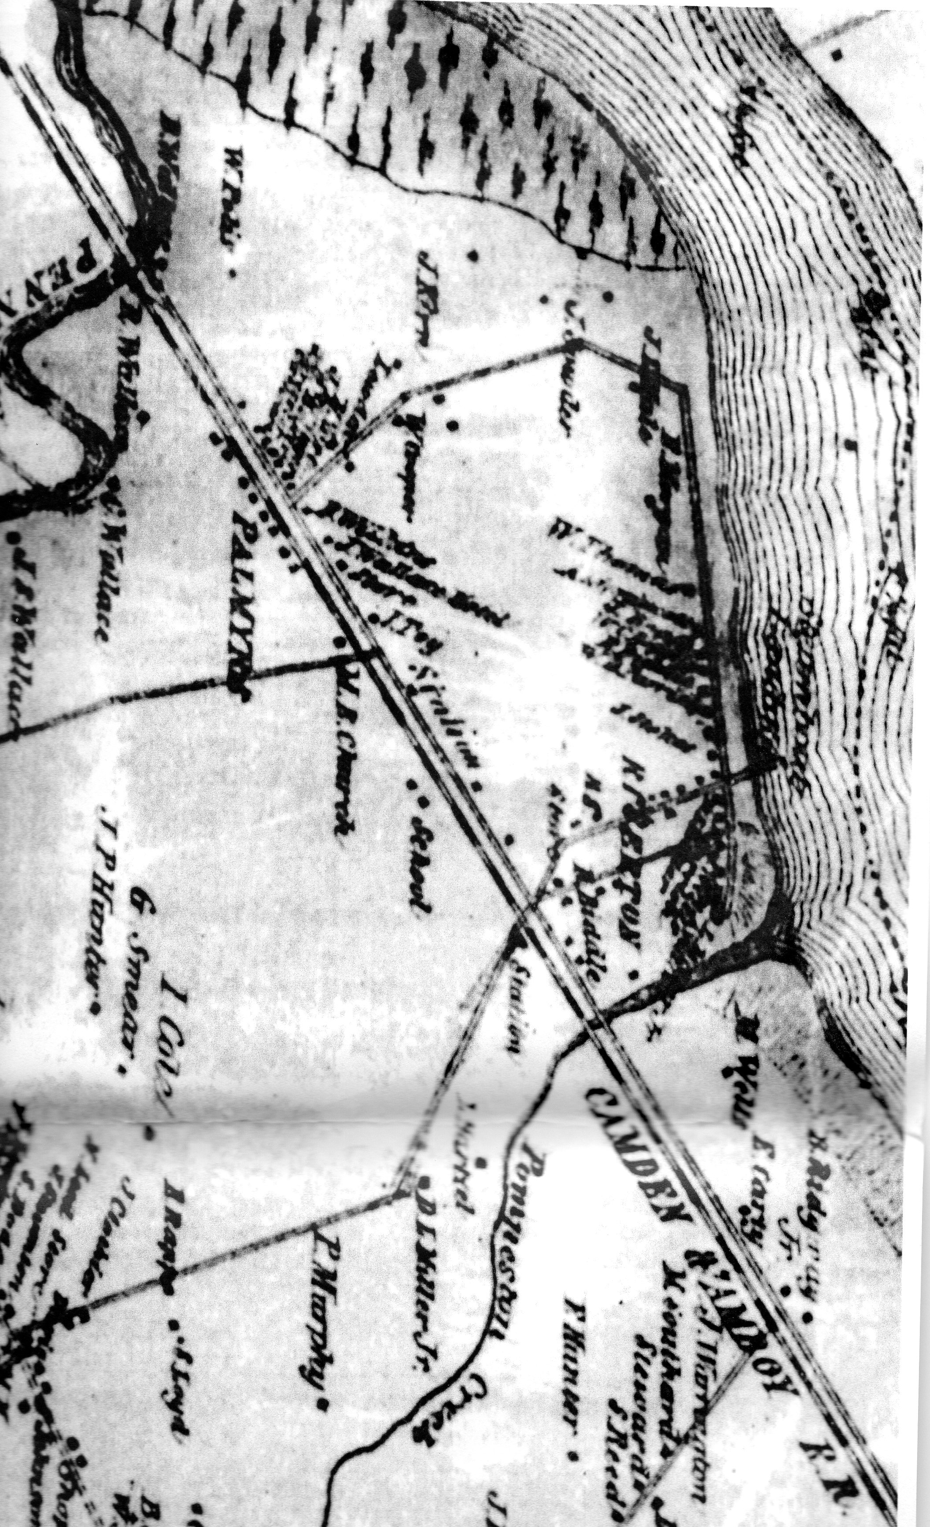
Palmyra was a distinct village located near the Camden and Amboy Railroad station, and Wells’ notes in the left margin of the census sheets indicated when he entered and left the village of Palmyra. Wells either did not collect, or did not find any residents who were blind, deaf, insane, or convicts, and even those who were born in countries where English was not the native language were not labeled as illiterate. He did record data on each adult’s occupation and value of real estate and personal savings, so we can draw a socio-economic sketch of Palmyra 154 years ago.
In 1860 Palmyra had a population 310 individuals in 62 families. Most, about 46%, were farmers or farm laborers, with others working as domestics, shoemakers or seamstresses. 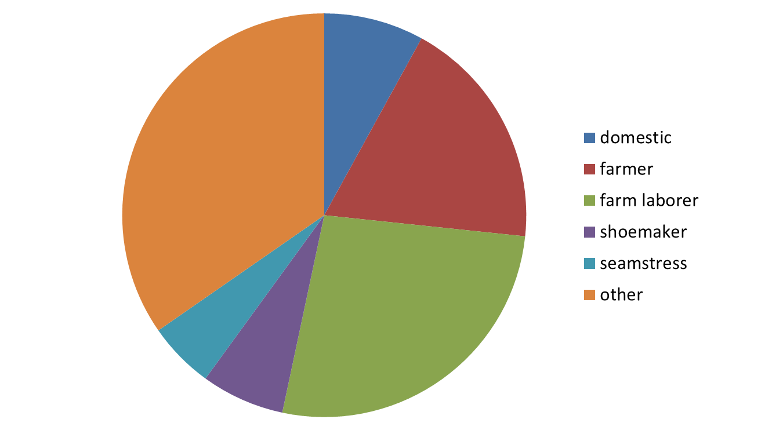Other occupations with three or fewer members were carpenter and laborer (3 each), store keeper, fisherman, gentlewoman (two each), basketmaker, clergy, bootmaker, nurse, hotelkeeper, ship carpenter, glass cutter, railroad laborer, gentleman, housekeeper, trader, physician, painter, and washerwoman (1 each).
Altogether these residents had assets worth $180,280 with $123,850 in real estate and $56,430 in cash. Twenty-six families owned no real property; they were probably renters or tenants. The Morgan, Toy, and Wallace families controlled 68% of the total value of the community.
It is difficult to evaluate what these figures meant for the citizens of Palmyra without some comparison. The neighboring community of Riverton had a population of 333 and $379,450 in assets. There were twenty-six farmers of farm laborers; Palmyra had thirty-four farmers or farm laborers. Riverton had fifteen gentlemen or gentlewomen and twenty-four domestics. Twenty-one families (40%) had $0 in real property and the “River” families (Robert Biddle, William Biddle, William Parrish, Caleb Clothier, Daniel Miller) controlled almost half of village’s monetary value.
The per capita worth for Westfield, roughly present day Cinnaminson was $729. Riverton’s per person worth was $1139 and Palmyra’s was $582. Palmyra was not as prosperous as its neighbors, but no head of household was a pauper with no real or no net property.
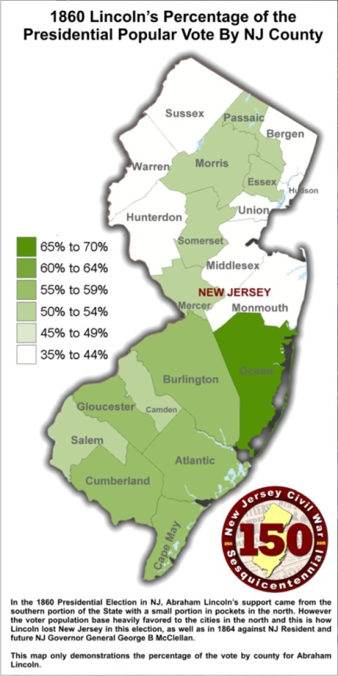
In the November presidential election, the New Jersey popular vote went to Stephen Douglas, but due to the number of “Democrat” contenders, Douglas received three of New Jersey’s electoral votes and Abraham Lincoln four. Burlington County supported Lincoln.

Following Lincoln’s election, the nation quickly erupted in civil war. In December, South Carolina seceded; in January 1861, Jefferson Davis was elected president of the Confederate States of America; in April, Fort Sumter was attacked; and on 21 July, Union troops were defeated at the First Battle of Bull Run. On 22 July, Congress had the states organize more regiments of troops, and posters like this showed up in New Jersey.
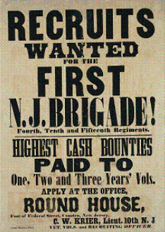

When the Fourth Regiment was formed, it had ten companies of about 100 men each, and one of these companies, Company E, sometimes called the “Spencer Guards” was commanded by Captain Charles Hall from Palmyra who kept the muster roll, which is on display here, and who also kept a personal diary of his first year in military service, which is also on display.
The Company E muster roll lists 97 men, and it is possible to find 35 of them on the 1860 census lists. With the census information, it is possible to draw more detailed portraits of these men since the census gives their marital status, occupations, and monetary worth. Eight are married with at least 18 children among them, but that includes Capt Hall, who had 8 children of his own. Eleven are farm laborers or farm apprentices, but only one is a farmer. Four have no occupation since they are young, but there are three laborers and three carpenters. Among these 35 soldiers, there are also a tinsmith, butcher, waterman, coach trimmer, apprentice harness maker, team driver, shoemaker, brick moulder and hoteler. Only four had any property, but one, the farmer, had land worth $12,000. Only eight had any net worth, the most possessing $500.
There are some photographs of what is referred to as the Fourth New Jersey Regiment, but these photos are probably of the Fourth New Jersey Militia Regiment, not the Fourth Regiment Infantry, New Jersey Volunteers.
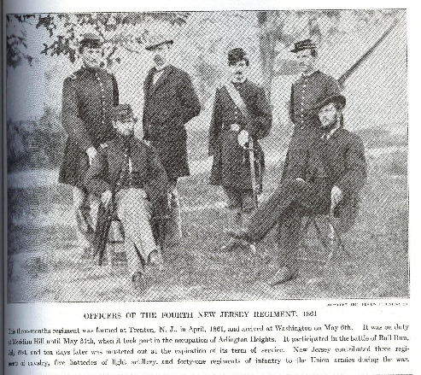

From http://www.bing.com/images/search?q=nj+4th+regiment&FORM=HDRSC2#view=detail&id=29E3DECBE615378349E56E557534B883C425AD14&selectedIndex=0
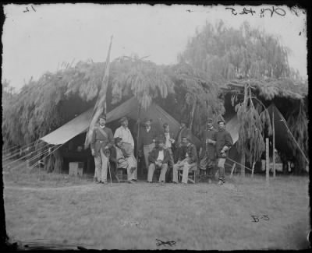
From http://www.fold3.com/document/260433988
After the company was mustered in, on 19 August 1861, it was deployed outside Alexandria, Virginia, in the area near the wooded space labeled “Seminary” on the map below to guard Washington, DC which is across the Potomac River.
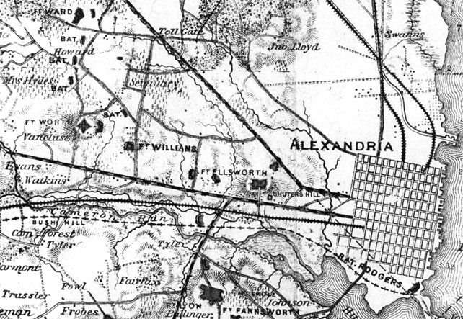

From http://kingst.com/tag/civil-war/
Genevieve Lumia has transcribed over half the diary and here is a typical entry.
Monday Nov 25th 1861 Cool, ice & ground frozen Self attended dress parade at 8 Oclock then went to Alexandria to get J Wilson … went to the Slave pens and found Wilson & brought him home & left him at the Guard house
The “Record of Officers and Men of New Jersey in the Civil War” which is online at https://wwwnet1.state.nj.us/DOS/Admin/ArchivesDBPortal/StrykerCivilWar.aspx was compiled in 1876 by William Stryker, Adjutant General of New Jersey. Capt Hall’s military service is recorded in the “Record” which is also referred to as the Stryker records, as is the military service of Pvt John Wilson, who deserted on 31 August 1862 from Fairfax, Virginia. Wilson’s behavior, which got him arrested, might have been a signal for his later action.
Hall wrote a somewhat detailed account of an incident related to picket duty, which was a constant responsibility of the soldiers outside Alexandria.
Friday Oct 18th cloudy. Sergeant Major Bonny was shot this morning and instantly killed by one of our pickets who hailed him and he did not answer and the picket fired twice, and although it was in the wood and perfectly dark and Raining, and the pickets fired only by hearing the noise yet a ball struck him in the neck & cut the bone in two, he jumped nearly 2 feet high and fell dead
The Stryker records mention that Sgt Major Thomas Bonney, Staff, 4th Regiment, was killed on the picket line at Mason’s Hill on 28 October. Since Hall was keeping a chronological record, his date of 18 October is probably correct, and the Stryker date a misprint. The Stryker record does not list this as a friendly fire incident, and Hall gives more information on this tragic death.
When perusing the Stryker reports, I noted that a Pvt John Parson, Co C, 4th Regiment, deserted 19 Oct from Camp Seminary. Parson had only enlisted on 2 October 1861, and his abrupt desertion suggests some connections to the Bonney incident. Did Parson shoot Bonney? As a raw recruit, perhaps assigned to the picket line, was Parson unprepared and untrained? While Hall has an explanation for the incident which excuses the guard, did Parson perhaps fear that an inquiry might ask him some questions which he was not comfortable answering? Just how loudly did he shout the sign? How long did he wait for a reply with the countersign? If his shot was so deadly, did he look carefully at his target? Or it is possible that a homesick Parson received a letter from his girlfriend on 19 October and decided that he needed to be back home.
Another incident involving a deserter received a great deal of attention from Hall, the Union troops, and the popular press.
Friday Dec 13th Beautiful Morning dress parade at 8 AM company parade at 10 ½ & target practice came in at 12 ½ 3 Oclock the whole Brigade marched out to witness a Military Execution a Deserter is to be shot this afternoon went out & witness the Execution Saw the man ride by in a wagon. Preceeded by his coffin & the 12 men that were detailed to shoot him heard the Report & then marched round & saw the dead man lying on ground after which we returned to Quarters and dismissed. Splendid & clear
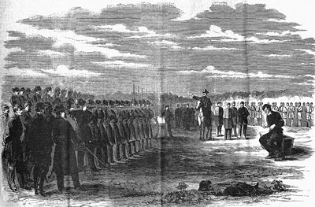
http://thomaslegion.net/americancivilwardesertionsdesertershistoryandfactshomepage.html
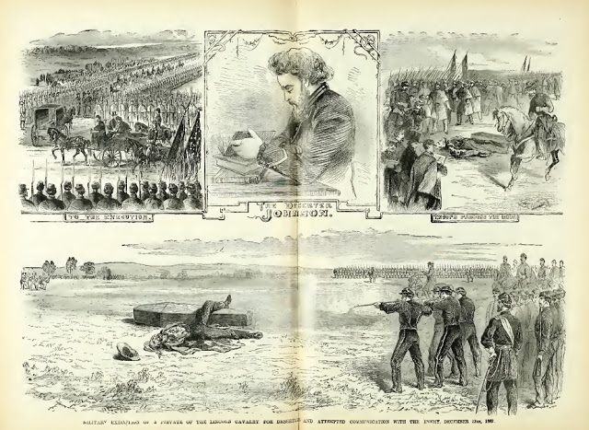
Another source gives more background and reflection on this event, which was widely reported in the popular press.
On the evening of December 4, 1861, Pvt. Johnson was on picket duty near Benton's Tavern, located on the south side of the intersection of the Little River and Columbia turnpikes, approximately seven miles west of Alexandria. After dinner, Johnson mounted his horse and started down Braddock Road towards Centreville, ostensibly to water his horse, but with the real intention of making it to the rebel lines. After riding several miles, he encountered a group of horsemen whom he presumed to be rebels. He identified himself to them as a Union deserter and offered to provide them the locations of his regiment's pickets. Unfortunately for Johnson, he had actually ran into a returning reconnaissance patrol from the 1rst New Jersey Cavalry. A Colonel Taylor promptly placed Johnson under arrest and delivered him to the Provost Marshal.
A general court martial was convened at the camp of Franklin's Division, located near Fairfax Seminary. In his defense, Johnson claimed that he had "not the slightest intention of deserting up to a few minutes before I started in the direction of the enemy's lines." He added that his desertion was motivated by a desire to visit his mother in New Orleans, spend a few weeks in the South and then return to his regiment, "perhaps with some valuable information." The Court was not buying this and believed Johnson had long contemplated desertion. Johnson was found guilty of desertion and sentenced to be shot by a firing squad.
Major-General George B. McClellan approved the sentence on December 11th, noting in his special orders that "for simple desertion, the penalty is death; for desertion coupled with such treachery, there can be no mercy." The published order was read to troops throughout the Army of the Potomac in order to make a strong and lasting impression.
From http://civilwarwashingtondc1861-1865.blogspot.com/2011/12/13-december-1861-execution-of-pvt.html
As the war dragged out and as the three-year enlistments of the men who enlisted in 1861 drew to a close, it was necessary to find new soldiers and a draft was instituted. Draftees could “hire” substitutes and 41 substitutes brought into unit Jan 65. Of this group, 24 deserted between March and June 1865 Company E was engaged at the siege of Petersburg, outside of Richmond, and fifteen substitutes deserted at Petersburg. Two were accused of going over to the enemy, which seems hard to believe since this was a nine-month long battle of attrition and the South was struggling to survive. The siege ended in April 1865 and shortly thereafter Lee surrenders. On 15 April Lincoln dies and in May, Jefferson Davis is captured. The war is over, but many soldiers remain on duty and nine of Company E’s substitutes deserted in June 1865 from Hall’s Hill, Virginia where the unit is stationed.
However, most of the unit did not desert at this time. Of the 97 men who enlisted in August 1861, seven deserted. Two walked out of hospitals and one deserter later re-enlisted. Thirty were discharged, most likely following prisoner exchanges with the rebels. A large number of the men in Company E were captured at the Battle of Gaines Farm, or Mill, in June 1861, and as a condition of their exchange, they had to promise not to fight again. Captain Hall was discharged for health reasons in September 1862. One trooper mustered out, two transferred, and the fate of one man is not recorded in the Stryker records.
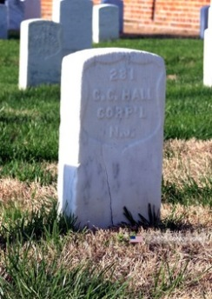
Eighteen of the original cohort died – eight of disease and ten killed in action. One who fell at Cold Harbor in June 1864 was Corporal Charles Carrol Hall, the second son of Capt Hall. Capt Hall never mentioned his son in his diary, and the son did not leave a diary of his own. It is known that Corporal Hall was, for some unknown reason, demoted to the rank of private in April 1863, but then re-promoted to corporal in May 1863. The attack on entrenched Confederate troops at Cold Harbor was considered as futile by many Union soldiers and Hall’s three-year enlistment would have expired in August, just two months after the battle. Corporal Hall is buried in the military cemetery at Mechanicsburg, Virginia.
Thirty-eight men of Company E remained in service until they were formally and officially discharged on 9 July 1865. Of the three men from Palmyra, William Polis returned home at the end of the war. There was not a parade or welcoming ceremony, as far as is known, but he probably saw his former commander, Charles Hall, who had been back at home in the village for almost three years.
Charles Hall died in 1899 and is buried in Morgan Cemetery. William Polis is buried about one hundred yards from where we are meeting, behind the audience in the Epworth Methodist Cemetery
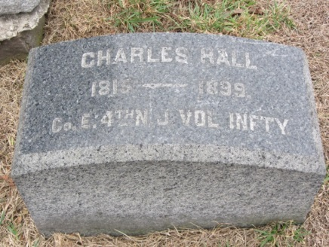
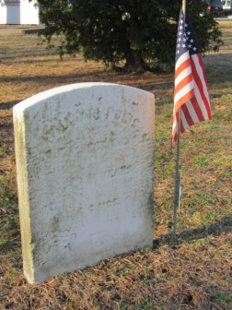

- Jay Howard 856.829.0612 jp912@hotmail.com
7 January 2014

